**Mother Cabrini Church**

**214 North Shamokin Street**

**Shamokin, PA, 17872**

**570-648-4512 (Parish Office)**

**570-644-0335 (Friary)**

**Website:**

<http://wwwrevivingtogether.com/>

**Thirtieth Sunday**

**in Ordinary Time**

**October 24, 2021**

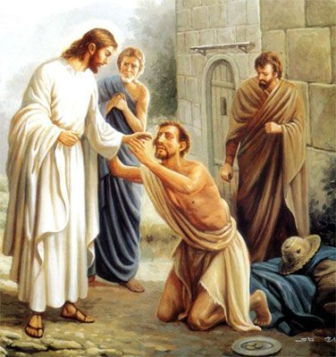

**Mother Cabrini Friary**

**Fr. Martin Kobos, OFM Conv.,** Pastor

**Friar Timothy Geiger, OFM Conv.,** Parochial Vicar

**Friar Michael Lasky, OFM Conv.,** Pastor of Our Lady of Hope & St. Patrick Churches

**Cabrini Parish Staff**

**Deacon Robert Wislock**, Pastoral Associate

**Ann Marie Drust,** Parish Secretary

**Jennifer Seidel,** Finance Manager

**Erik Seidel,** Music Director

**Judy Surak,** Religious Education Director

**Cabrini Mass Schedule**

**Weekends: Saturday,** 4PM Vigil – Sunday: 7AM, 8:45AM & 11AM

**Daily Masses:** Monday through Saturday, 8AM

**Holy Days of Obligation:** As Announced

**Cabrini Confessions**

**Tuesday and Thursday:** 7:30 – 7:50AM

**Saturday:** 3:00 to 3:45PM

***Mass Intentions***

**SATURDAY, OCTOBER 23 – Vigil Mass**

4PM +David Philips by Wife, Marie & Sons,

Brian & David Kyle

**SUNDAY, OCTOBER 24**

**Thirtieth Sunday in Ordinary Time**

7AM +Mary Santor by +Husband, Carl

8:45AM Parish Family of Mother Cabrini Church

11AM +Eleanor Olcese by Daughter, Sue & Family

**MONDAY, OCTOBER 25**

**Thirtieth Week in Ordinary Time**

8AM +Kevin Malukas by David & Patricia

(Kazmerski) Carey

**TUESDAY, OCTOBER 26**

**Thirtieth Week in Ordinary Time**

8AM +Thomas Weaver by Sandy & Rich McDonald

**WEDNESDAY, OCTOBER 27**

**Thirtieth Week in Ordinary Time**

8AM +Anthony Varano by Uncle Lou

and Aunt Bernie Rauco

**THURSDAY, OCTOBER 28**

**Ss. Simon & Jude**

8AM +Robert R. Yakoboski by Wife, Dorothy

and Son, David

**FRIDAY, OCTOBER 29**

**Thirtieth Week in Ordinary Time**

8AM +Arthur Kopyscianski by Wife, Rose Marie

**SATURDAY, OCTOBER 30**

**Thirtieth Week in Ordinary Time**

8AM ++Hattie & Chet Andruskiewicz

by Dennis Andruskiewicz & Family

4PM +Robert Laczkowski by Bonnie Laczkowski

**SUNDAY, OCTOBER 31**

**Thirty-First Sunday in Ordinary Time**

7AM +Valerian Stefanowicz by Daughter, JoAnn

8:45AM +Stanley Kalinoski

by Pat & Peggy Kazmerski

11AM Parish Family of Mother Cabrini Church

**Our Church Bells are Ringing this Week. . .**

In Memory of Leonard Shipkoskie

by Mary and Tom Harmon

**Collection Totals for the**

**Weekend of October 17, 2021**

Offertory: $3,851.00

Property Maintenance: 559.00

Parish Dues: 159.00

All Souls: 857.00

Total: $5,426.00

World Mission: $ 40.00

Franciscan Fathers: $ 20.00

**Remember, the Bill-Collector**

**Always Shows Up!!**

When circumstances prevent you from attending Mass on a particular weekend, please remember to bring and add your offertory envelopes to the following week's collection.  The parish builds its annual budget based on projected income and projected expenses.  Shortfalls in any weekend collection income strains our ability to pay our regular occurring parish bills.  Thank you and God bless all who support their parish, in good times and in bad, in sickness and in health and whether in town or not! *Fr. Martin*

***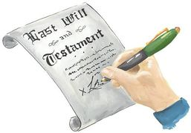*Express Your**

**“Will Power”**

If you haven’t done so already, you can include Mother Cabrini Parish in your will through the use of a codicil. Your attorney can advise you on how easy adding a codicil can be.

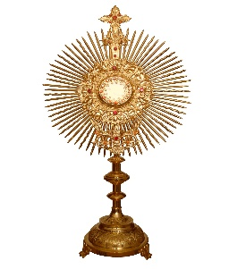**Kudos! Thanks! & Applause! to. . .**

The wonderful group of parishioners who gave of their time, talent and treasure to ensure the success of our annual Chicken BBQ which took place Sunday, October 10th. Like a well-oiled machine, volunteers gathered the day before the BBQ to prepare the potatoes, the beans, cranberry sauce containers, take out boxes etc. At the crack of dawn on Sunday morning, gentlemen came to start the charcoal fire at the Shed. All the Hail Mary’s worked and the potential for rain did not materialize. 260 chicken halves were barbequed and prepared for distribution. Thanks to: to our hardworking kitchen crews; the dedicated drivers who delivered over 60 platters to our local hi-rise customers; to all parishioners who purchased and sold tickets to family & friends; and to our generous “BBQ Benefactors” who made monetary contributions which brought down our overhead substantially thus increasing our profit. And at the end of it all, folks stayed back to clean up the Shed kitchen in preparation for pierogi production which began the following week. To everyone who contributed to the effort, a most sincere note of thanks and appreciation! Well done!

*Fr. Martin*

**2022 MASS BOOK INFORMATION**

[](javascript:edit(9706))The parish Mass book for special wedding anniversaries, i.e. 25th, 40th, 50th, etc. opened last week. Now, the Mass book is open for general reservations to all. To be fair to all, kindly keep in mind that our policy is that one weekend Mass and one weekday Mass may be scheduled per family. Beginning January 11, 2022, unlimited number of Masses may be scheduled in the parish. Undated Masses, celebrated by the Friars in different locations may be reserved at your convenience anytime throughout the year.

**Reserve the dates. . .**

**CABRINI PARISHIONERS**

Strengthen your faith during our 40 Hour Devotions 7PM, November 14th, 15th & 16th. Carve out just a little time to be with the Lord at this graced time.

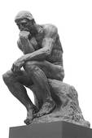**PONDER POINT**

“O Lord our God, how Glorious is

your name above all the earth! You have exalted your majesty above

the heavens.”

*Psalm 8:2*

**ALL SOULS REMEMBRANCE . . .**

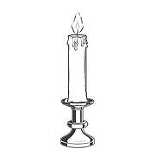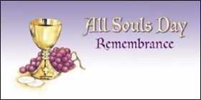Please be sure to return your ***All Souls Envelopes*** in the collection basket or at the parish office **no later than NOON on Monday, October 25th** so that they can be placed on the altar in time for the All Souls Novena.

*Eternal rest grant unto them*

*O Lord and let perpetual light*

*shine upon them.*



**If you see Fr. Martin on Sunday, November 7th, wish him a Happy Birthday!**

***CHANGE OF ADDRESS and PHONE NUMBER:***

******A reminder to please contact the parish office with a change of address and/or your telephone number. You are important to us and at times we may need to contact you by either phone or mail. When mail is returned to the parish office we are charged a return fee.

**Please Pray For the Sick***,* especially, Ann Barber, Bob Hauer, Jim Logic, Kapukui Sykes, Justin Wachter, Candida Davis, Matthew (Butch) Menapace, Betty Menapace, Dennis Shuey, Pete, Ginther, “Henry", George Klemick, Connie Yucha, Audrey Spaulding, Kathy Marquez, Alex & Shirley Stefanowicz, Gertrude Slawek, Pete Yucha, Allen Hornberger, Mark Senoski, Cassandra Senoski, Roberta Jasper, Marge Schiccatano, Thomas & Sylvia Pappas, Barbara A. Verano, Jaden Leiby, Lorraine Gusick, Dan Noll, Mark M., Mark Krzykwa, John Rauch, Joe Hamilton, Joanne (Cherry) Bailer, Frank and Kathy Purcell, Rose Marie Dunick, Elizabeth Purcell, Ed Griffiths, Katie Bolick, Diane Knorr, John Nolter, Christian Eby, Connie Fabrizio and Fr. Steven Frenier, OFM Conv., Craig Fetterman, Chrissy Geiswite, Bob Barrett, Diane Kolovich, Bonnie Snyder, Mary Harmon, Mary Ellen Candelora, Dorothy Yakoboski, Jacqueline Robel, Sharon Casper and Berna Surak.



**Bereavement Ministry for our**

**3 Franciscan Parishes**

For many years, Saint Patrick Parish has enjoyed having an excellent Bereavement Ministry. Due to Covid, the last year and a half has kept us from having in-person meetings. Nevertheless, we are still writing letters and checking in on those who have recently lost a loved one. If you are interested in becoming part of our Team, as we expand this ministry to include all 3 of our Franciscan Parishes, please call Linda Young

at St. Patrick 570-797-8251.

We are planning an informational meeting

in the near future.



***PLEASE PRAY FOR OUR TROOPS AND THEIR FAMILIES***

**Mother Cabrini Memorials**

**In Memory of Patrick Joseph Latsha**

$200 by Mary Solomon, Diana Jackson,

Janet Tomcavage, Joann Sciandra

and Jami Marks

$150 by Linda and Tony Getchey & Family

$100 by James and Christina Letcavage

$ 50 by Susan and Robert Varano

$ 50 by Amy Balascik

$ 50 by The Jeremiah’s: John, Kathy, Kyle,

Jake and Emma, & Haile Kimsal

$ 50 by Marcia and Jim Bowers

$ 50 by Anella Kauffman

$ 25 by Lee Spock and Family

$ 25 by Phil and Sherry Dambrosia

$ 25 by Joe and Linda Bielski & Family

$ 20 by Aldo Mirarchi

**Remembrance Opportunities**

**For Your Loved Ones. . .**

The parish has a wonderful array of remembrance opportunities for both, the living and deceased. You may honor your loved one’s memory or celebration of a special occasion, like a birthday or an anniversary by offering the flowers by the tabernacle, the candles used at Mass, the bread and wine offered at Mass, the Sanctuary candle, the church bells, etc. What a meaningful way to honor them on their special date! Reserve dates are filling up quickly so call the parish office to make your reservation.

**Our Lady of Hope Basket Raffle** will continue to be held on Saturday and Sunday, October 23rd and 24th and October 30th and 31st.  Doors will also be open from 5PM to 7PM on Thursday & Friday, October 21st and 22nd, Sunday, October 24th, Tuesday, October 26th & Friday October 29th. ***The raffle will be held in the school basement next to the Church*** from 8AM to 12:30PM.  Come visit and take some chances on the many theme baskets and gift certificates. The drawing for the baskets will take place on Sunday, October 31st.

****We celebrate the feast of Saints Simon and Jude, the Apostles, on Thursday, October 28. Both of these ordinary men were chosen and commissioned by Jesus Christ “to make disciples of all nations.” (Matthew 28:19) These two Apostles were known as Simon the Zealot and Jude Thaddeus. Both witnessed the many miracles that Christ performed, attended the Last Supper, and saw Jesus ascend into heaven.

Catholic tradition explains that after preaching the Gospel in Egypt, Simon joined Jude to bring the Good News to the people in Persia and Armenia, where both were martyred in 65 AD. The examples of these saints encourage each of us as Jesus’ disciples to share the Good News of Our Lord with all that we meet in our daily lives. St. Simon is the patron saint of couriers and St. Jude, the patron saint of hopeless or lost causes and hospital workers.

May we pray on this feast of these two saints,” Father, you revealed yourself to us through the preaching of your apostles Simon and Jude. By their prayers, give your Church continued growth and increase the number of those who believe in you. Through our Lord Jesus Christ, your Son, who lives and reigns with you in the unity of the Holy Spirit, God, for ever and ever.” (*Christian Prayer Book*)



**OUR LADY OF MOUT CARMEL CHURCH**

**SPAGHETTI DINNER SUNDAY NOVEMBER 14th**

11:00AM to 1:00PM - Our Lady’s Parish Hall

47 South Market Street Mount Carmel PA

Take Outs Only - No Containers needed

Menu: Spaghetti, meatballs, salad, bread

and dessert! - Donation $10.00



**DIVINE REDEEMER CHURCH**

**Holiday Faire**

**Divine Mercy Hall**

**400 Block of West Cherry Street, Mount Carmel**

**SATURDAY, NOVEMBER 13, 2021**

**11:00 AM to 5:00 PM**

**FOOD** ◊ BAKE SALE

**HOLIDAY THEMED BASKETS**

**OFFICE ENTRANCE**

**438 West Avenue, Mount Carmel**

**BASKETS ONLY!**

**Friday, November 12th, 6:00 PM to 8:00 PM**

**Saturday, November 13th, 11:00 AM to 6:00 PM**



**St. Pauline Foundation**

**Holiday Raffle**

Friday, November 12, 2021 – 12Noon to 6PM.

Saturday, November 13, 2021 – 11AM to 5PM

Location: St. Pauline Center

1150 Chestnut Street, Kulpmont, PA

Parking in rear/Handicap accessible

Homemade food and baked goods will be available next door at the Pauline House.

Come early as we usually sell out of food.

There will be over 200 items, including a

gas grill, fire pit, 5 piece table set, electric turkey fryer, large electric lantern heater, microwave

and TV to name a few.

**Social distancing and masks recommended.**



**30th Sunday in Ordinary Time**

**24 October 2021**

**Introductory Rites  
  
Entrance Antiphon**

Let the hearts that seek the Lord rejoice; turn to the Lord and his strength; constantly seek his face.

*Cf. Ps 105 (104):3-4*  
  
**Gloria**

*(When it is prescribed, this hymn is either said or sung:)*  
  
**Glory to God in the highest, and on earth peace to people of good will.  
We praise you, we bless you, we adore you, we glorify you, we give you thanks for your great glory,  
Lord God, heavenly King, O God, almighty Father.  
Lord Jesus Christ, Only Begotten Son, Lord God, Lamb of God, Son of the Father,  
you take away the sins of the world, have mercy on us;  
you take away the sins of the world, receive our prayer;  
you are seated at the right hand of the Father, have mercy on us.  
For you alone are the Holy One, you alone are the Lord,  
you alone are the Most High, Jesus Christ,  
with the Holy Spirit, in the glory of God the Father. Amen.**

**Collect**

Almighty ever-living God, increase our faith, hope and charity, and make us love what you command,  
so that we may merit what you promise. Through our Lord Jesus Christ, your Son, who lives and reigns with you in the unity of the Holy Spirit, God, for ever and ever. **Amen.**  
  
Jeremiah 31:7-9  
Thus says the Lord: Shout with joy for Jacob, exult at the head of the nations; proclaim your praise and say: The Lord has delivered his people, the remnant of Israel. Behold, I will bring them back from the land of the north; I will gather them from the ends of the world, with the blind and the lame in their midst, the mothers and those with child; they shall return as an immense throng. They departed in tears, but I will console them and guide them; I will lead them to brooks of water, on a level road, so that none shall stumble. For I am a father to Israel, Ephraim is my first-born.  
  
**Psalm 126**

**R. The Lord has done great things for us; we are filled with joy.**

When the Lord brought back the captives of Zion, we were like men dreaming. Then our mouth was filled with laughter, and our tongue with rejoicing. **R.**

Then they said among the nations, “The Lord has done great things for them.”

The Lord has done great things for us; we are glad indeed. **R.**

Restore our fortunes, O Lord, like the torrents in the southern desert.

Those that sow in tears shall reap rejoicing. **R**.

Although they go forth weeping, carrying the seed to be sown,  
They shall come back rejoicing, carrying their sheaves. **R.**  
  
**Hebrews 5:1-6**

Brothers and sisters: Every high priest is taken from among men and made their representative before God, to offer gifts and sacrifices for sins. He is able to deal patiently with the ignorant and erring, for he himself is beset by weakness and so, for this reason, must make sin offerings for himself as well as for the people. No one takes this honor upon himself but only when called by God, just as Aaron was. In the same way, it was not Christ who glorified himself in becoming high priest, but rather the one who said to him:

*You are my son:* *this day I have begotten you;*  
just as he says in another place: *You are a priest forever according to the order of Melchizedek.*

**Gospel Acclamation**

**Alleluia, alleluia.**  
Our Savior Jesus Christ destroyed death and brought life to light through the Gospel. *Cf. 2 Tm 1:10*  
**Alleluia, alleluia.**  
  
**Mark 10:46-52**

As Jesus was leaving Jericho with his disciples and a sizable crowd, Bartimaeus, a blind man, the son of Timaeus, sat by the roadside begging. On hearing that it was Jesus of Nazareth, he began to cry out and say, “Jesus, son of David, have pity on me.” And many rebuked him, telling him to be silent. But he kept calling out all the more, “Son of David, have pity on me.” Jesus stopped and said, “Call him.” So they called the blind man, saying to him, “Take courage; get up, Jesus is calling you.” He threw aside his cloak, sprang up, and came to Jesus. Jesus said to him in reply, “What do you want me to do for you?” The blind man replied to him, “Master, I want to see.” Jesus told him, “Go your way; your faith has saved you.” Immediately he received his sight and followed him on the way.

**Profession of Faith**

**I believe in one God, the Father almighty, maker of heaven and earth,  
of all things visible and invisible. I believe in one Lord Jesus Christ,  
the Only Begotten Son of God, born of the Father before all ages.  
God from God, Light from Light,true God from true God,  
begotten, not made, consubstantial with the Father;  
through him all things were made. For us men and for our salvation   
he came down from heaven,***(At the words that follow, up to and including and became man, all bow.)*

**and by the Holy Spirit was incarnate of the Virgin Mary,  
and became man. For our sake he was crucified under Pontius Pilate,   
he suffered death and was buried, and rose again on the third day  
in accordance with the Scriptures. He ascended into heaven  
and is seated at the right hand of the Father. He will come again in glory  
to judge the living and the dead and his kingdom will have no end.  
  
I believe in the Holy Spirit, the Lord, the giver of life, who proceeds from the Father and the Son,  
who with the Father and the Son is adored and glorified, who has spoken through the prophets.  
  
I believe in one, holy, catholic and apostolic Church. I confess one Baptism for the forgiveness of sins and I look forward to the resurrection of the dead and the life of the world to come. Amen.**

*(The Apostles’ Creed may be used instead of the Nicene Creed.)*

**The Apostles’ Creed**

**I believe in God, the Father almighty, Creator of heaven and earth,**

**and in Jesus Christ, his only Son, our Lord,**

**who was conceived by the Holy Spirit, born of the Virgin Mary,**

**suffered under Pontius Pilate, was crucified, died and was buried;**

**he descended into hell; on the third day he rose again from the dead;**

**he ascended into heaven, and is seated at the right hand of God the Father almighty;**

**from there he will come to judge the living and the dead.**

**I believe in the Holy Spirit, the holy catholic Church,**

**the communion of saints, the forgiveness of sins, the resurrection of the body,**

**and life everlasting. Amen.**

**Prayer over the Offerings**

Look, we pray, O Lord, on the offerings we make to your majesty, that whatever is done by us in your service may be directed above all to your glory. Through Christ our Lord. **Amen.**  
  
**Communion Antiphon**

We will ring out our joy at your saving help and exult in the name of our God. *Cf. Ps 20 (19):6*  
**OR**  
Christ loved us and gave himself up for us, as a fragrant offering to God. *Eph 5:2*  
  
**Prayer after Communion**

May your Sacraments, O Lord, we pray, perfect in us what lies within them, that what we now celebrate in signs we may one day possess in truth. Through Christ our Lord. **Amen.**

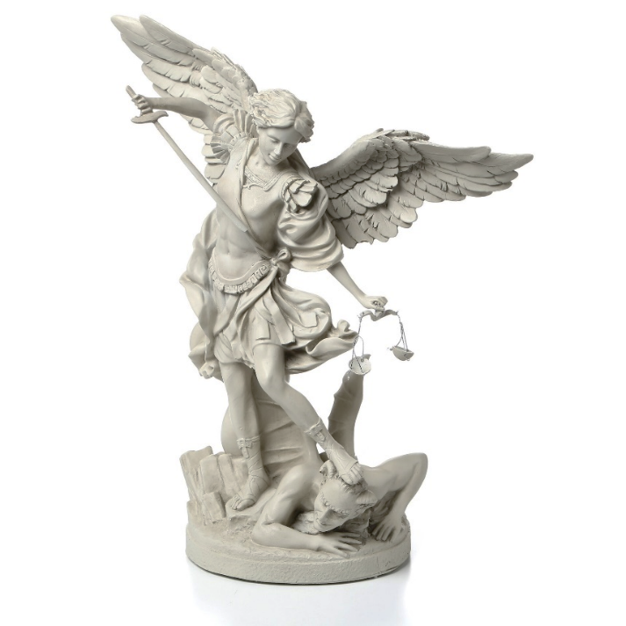

**Prayer to St. Michael the Archangel**

St. Michael the Archangel, defend us in battle.

Be our defense against the wickedness and snares of the Devil. May God rebuke him, we humbly pray, and do thou,

O Prince of the heavenly hosts, by the power of God, thrust into hell Satan, and all the evil spirits, who prowl about the world seeking the ruin of souls. Amen.