**Mother Cabrini Church**

**214 North Shamokin Street**

**Shamokin, PA, 17872**

**570-648-4512 (Parish Office)**

**570-644-0335 (Friary)**

**Website:**

<http://wwwrevivingtogether.com/>

**Thirty-Third Sunday**

**in Ordinary Time**

**November 14, 2021**

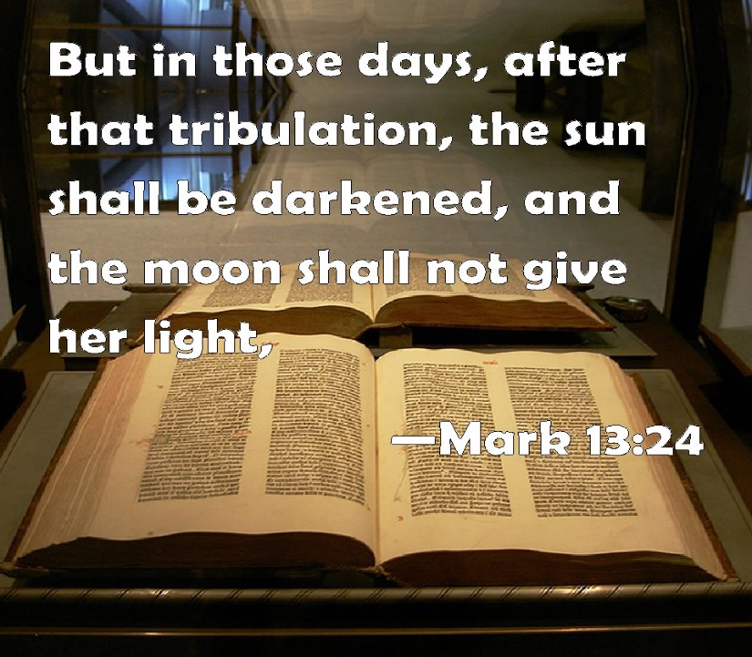

**Mother Cabrini Friary**

**Fr. Martin Kobos, OFM Conv.,** Pastor

**Friar Timothy Geiger, OFM Conv.,** Parochial Vicar

**Friar Michael Lasky, OFM Conv.,** Pastor of Our Lady of Hope & St. Patrick Churches

**Cabrini Parish Staff**

**Deacon Robert Wislock**, Pastoral Associate

**Ann Marie Drust,** Parish Secretary

**Jennifer Seidel,** Finance Manager

**Erik Seidel,** Music Director

**Judy Surak,** Religious Education Director

**Cabrini Mass Schedule**

**Weekends: Saturday,** 4PM Vigil – Sunday: 7AM, 8:45AM & 11AM

**Daily Masses:** Monday through Saturday, 8AM

**Holy Days of Obligation:** As Announced

**Cabrini Confessions**

**Tuesday and Thursday:** 7:30 – 7:50AM

**Saturday:** 3:00 to 3:45PM

***Mass Intentions***

**SATURDAY, NOVEMBER 13 – Vigil Mass**

4PM ++Al & Violet DuDeck by Bill & Pat Barrett

**SUNDAY, NOVEMBER 14**

**Thirty-Third Sunday in Ordinary Time**

7AM Parish Family of Mother Cabrini Church

8:45AM +Chet Andruskiewicz

by Andruskiewicz Children

11AM ++Dolores & John Vanaskie by Children

**MONDAY, NOVEMBER 15**

**St. Albert the Great**

8AM ++Genevieve & Joseph Kobos by Children

**TUESDAY, NOVEMBER 16**

**Ss. Margaret of Scotland & Gertrude**

8AM ++Deceased Parents, Relatives

& Benefactors of the Franciscan Order

**WEDNESDAY, NOVEMBER 17**

**St. Elizabeth of Hungary**

8AM Living Parents, Relatives & Benefactors

of the Franciscan Order

**THURSDAY, NOVEMBER 18**

**The Dedication of the Basilica of Ss. Peter & Paul & St. Rose Phillipine Duquesne**

8AM ++Ann, Ed & Chris Petroskie & Jim and

Audrey Shaffer by Rose Marie

**FRIDAY, NOVEMBER 19**

**Thirty-Third Week in Ordinary Time**

8AM +Stanley Kalinoski by Jack Coleman

**SATURDAY, NOVEMBER 20**

**Thirty-Third Week in Ordinary Time**

8AM ++Joyce & Bob Dilliplane by Sisters

4PM ++Paul & Pearl Urick by Family

**SUNDAY, NOVEMBER 21**

**Our Lord Jesus Christ, King of the Universe**

7AM + +Julia & Herbert Krepshaw

by Gary & Bernice Madden

8:45AM Parish Family of Mother Cabrini Church

11AM ++Rose & Ed Bolick by Family

**Tabernacle Flowers I & II**

In Memory of Joseph and Genevieve Kobos

by Children

**Our Church Bells**

**are Ringing this Week. . .**

In Memory of Patrick J. Kazmerski, Jr.

by Mom, Dad, Trisha, Dave, Linda, Mike & Michael

**Collection Totals for the**

**Weekend of November 7, 2021**

Offertory: $5,121.13

Winter Fuel: 686.00

Parish Dues: 239.00

40 Hour Flowers: 167.14

All Saints: 197.00

All Souls: 37.00

Total: $6,448.27

Franciscan Mission: $ 39.00

World Mission: 45.00

**Remember, the Bill-Collector**

**Always Shows Up!!**

When circumstances prevent you from attending Mass on a particular weekend, please remember to bring and add your offertory envelopes to the following week's collection.  The parish builds its annual budget based on projected income and projected expenses.  Shortfalls in any weekend collection income strains our ability to pay our regular occurring parish bills.  Thank you and God bless all who support their parish, in good times and in bad, in sickness and in health and whether in town or not! *Fr. Martin*



**PONDER POINT**

“Behold the Lamb of God, who takes away the sins of the world!”

*Jn 1:29*

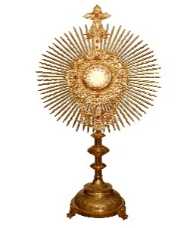**Mother Cabrini 40 Hours Devotion, November 14th, 15th & 16th – St. Anthony Relic to be Present**

We are pleased to announce that Fr. Richard Jacob Forcier, OFM Conv. will be our guest homilist for these three evenings, honoring our Lord, present in the Holy Eucharist. Fr. Richard comes to us with a wealth of experience serving as a high school and college-seminary teacher, pastor and an administrator in our Franciscan community. He currently serves as Secretary of our Franciscan, *Our Lady of the Angels Province* as well as Director of the Shrine of St. Anthony in Ellicott City, Maryland. As part of Fr. Richard’s reflection on The Holy Eucharist, he will be bring the shrine’s 1st class relic of St. Anthony, who had a profound devotion to our Lord in the Blessed Sacrament. Please plan to be with us to be spiritually refreshed during these blessing filled days at Mother Cabrini Parish. *Fr. Martin*

**Calling Forth A Few Good People**

In collaboration with our two neighboring parishes of Our Lady of Hope and St. Patrick, an Evangelization Team and Planning Committee is being organized to strengthen our faith and reinvigorate our parishes in the post Covid era. If you would wish to be considered as a potential member of this team (each parish will have four representatives), please contact Fr. Martin or call the parish office and leave your name.

**Heart Felt Thanks!** to. . . . Bob and Karol Freiler who donated the entire cost of supplying Mother Cabrini Parishioners with the ***2021 Advent Edition of “5 Minutes a Day”.*** This loving pre-Christmas donation was given in ***Loving Memory of the Deceased Members of the Freiler and Church Families*.**  Many thanks Bob and Karol for supporting our spiritual Advent journey to Christmas through these daily meditations!

**Job Opening at**

**Mother Cabrini**

After ten years of faithful service as Custodian at Mother Cabrini Parish, Michael Toucheloskie will be “retiring” at the end of this calendar year. I take this opportunity to express my deepest appreciation and thanks to Mike for his faithful decade of service to the parish. His diligence and attention to his various responsibilities in this position has been a great asset to me in helping to keep the Cabrini Campus in good order.

Effective immediately, the parish invites interested applicants to stop by the parish office to pick up a job description to fill this position. The position is for 25 hours/week. This position will begin January 2, 2022. Appropriate references and clearances will be necessary. Please contact Jen Seidel at the parish office with any questions.

**Christmas Giving Lottery Calendars, Now Available!**

Hot off the press and available just in time for your Christmas gift giving or as a “Stocking Stuffer,” our Mother Cabrini **January 2022**

Lottery Calendars are now in the Parish Office. Calendars are $5 each. Based on past experience, these Holiday Calendars go

quickly so don’t delay.

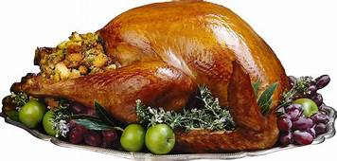﻿**The Shamokin Knights of Columbus will be serving Free Thanksgiving Dinners** on Thursday November 25th from 11:00-2:00 at the Knights Hall 400 E Independence St in Shamokin. Eat in or take out available. Shut-ins who would like a meal delivered please contact the parish office

at 570-648-4512.  The Knights are accepting donations to help offset the cost of the meal along with donations of turkeys

and desserts.

**Please Pray For the Sick***,* especially, Ann Barber, Bob Hauer, Jim Logic, Kapukui Sykes, Justin Wachter, Candida Davis, Matthew (Butch) Menapace, Betty Menapace, Dennis Shuey, Pete, Ginther, “Henry", George Klemick, Connie Yucha, Audrey Spaulding, Kathy Marquez, Alex & Shirley Stefanowicz, Gertrude Slawek, Pete Yucha, Allen Hornberger, Mark Senoski, Cassandra Senoski, Roberta Jasper, Marge Schiccatano, Thomas & Sylvia Pappas, Barbara A. Verano, Jaden Leiby, Lorraine Gusick, Dan Noll, Mark M., Mark Krzykwa, John Rauch, Joanne (Cherry) Bailer, Frank and Kathy Purcell, Rose Marie Dunick, Elizabeth Purcell, Ed Griffiths, Katie Bolick, Diane Knorr, John Nolter, Christian Eby, Connie Fabrizio and Fr. Steven Frenier, OFM Conv., Craig Fetterman, Chrissy Geiswite, Bob Barrett, Diane Kolovich, Bonnie Snyder, Mary Ellen Candelora, Dorothy Yakoboski, Jacqueline Robel, Sharon Casper, Sharon Rome, Berna Surak and Mary Beth Hanadel.



**Fall Food and Bake Sale:** St. Patrick Church, Trevorton will hold a Soup, Pigeon & Bake Sale in the Parish Hall on Friday, November 19 – 4PM to 7PM and Saturday, November 20th – 11AM to 2PM. A variety of delicious homemade Soups & Baked Goods.

**Red Cross Bloodmobile**: On Monday, November 15, from 1:00-6:00PM, Holy Angels Parish, Kulpmont will sponsor a Bloodmobile in the Activity Center. If you are physically able to give blood, we ask that you strongly consider giving the gift of life. For more information, please call 1-800-733-2767. Please remember to wear your mask.**Scheduled Appointments Are Strongly Recommended!**

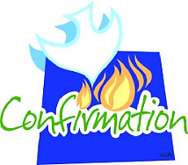

**Confirmation Sponsor Discernment Meeting**

Sunday, December 5, 2021, 9:45AM – Our Lady of Hope Church. Parents/Guardians of all 6th, 7th & 8th grade. Religious Education and Lourdes Students.

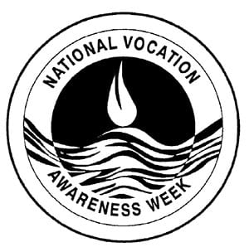

**Church Celebrates Vocation**

**Awareness Week**

National Vocation Awareness Week, celebrated **November 7-13, 2021**, is an annual week-long celebration of the Catholic Church in the United States dedicated to promoting vocations to the priesthood, diaconate, and consecrated life through prayer and education, and to renew our prayers and support for those who are considering one of these particular vocations.

Parents, grandparents and mentors of young people, please encourage conversations among the young of our Catholic community of how God may be calling them to a life of ministry and service as a priest, a deacon or consecrated religious. In the past, the Coal Region was especially fruitful with vocations and in particular to the Franciscan Family. Feel free to speak with any of the local Friars for additional information.

**GOSPEL WORD SEARCH**

**DISTRESS DAYS MOON**

**STARS BRIGHTNESS ANGELS**

**WINDS WORLD FIG**

**TREE TWIGS SUN**

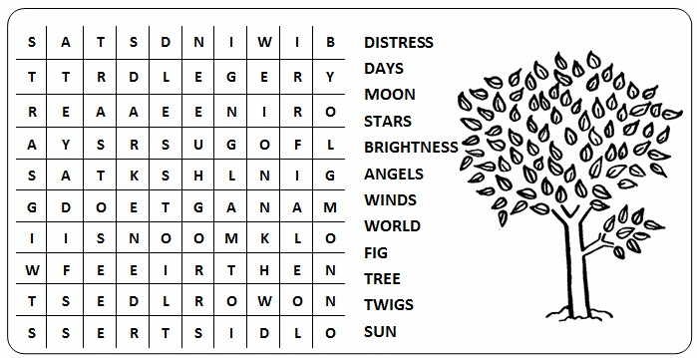

****The feast of St. Elizabeth of Hungary will be celebrated on Wednesday, November 17th. St. Elizabeth, the daughter of the King of Hungary, was born in 1207. She devoted herself to a life of penance and a great love for the poor and the suffering. Her service to those in need helped her become the patroness of all Catholic Charities and the Secular Franciscan Order.

At the age of 14, Elizabeth married and had three children. Throughout her life, she dressed in simple clothes and distributed bread to the people on a daily basis.

Pope Emeritus Benedict XVI explained that Elizabeth “diligently practiced works of mercy. She would give food and drink to those who knocked at her door, she procured clothing, paid debts, cared for the sick and buried the dead. Coming down from her castle, she often visited the homes of the poor bringing them bread, meat, flour and other food. She distributed the food personally and attentively checked the clothing and mattresses of the poor. She lived a life of service to justice and charity, in the constant search for the common good.”

As a Secular Franciscan, she also cared for the sick at a hospital that she founded in honor of St. Francis of Assisi. She died before her 24th birthday and was canonized a saint four years later. St. Elizabeth is the patron saint of bakers, hospitals, brides, homeless and charities.

On her memorial, may we pray, “Almighty God, by whose grace your servant Elizabeth of Hungary recognized and honored Jesus in the poor of this world; Grant that we, following her example, may with love and gladness serve those in need.”



***PLEASE PRAY FOR OUR TROOPS AND THEIR FAMILIES***

**ST. MAXIMILIAN KOLBE WEEKEND:**

**MILITIA OF THE IMMACULATA (MI)**

**CONSECRATION TO MARY**

****With a view to promoting consecration to the Immaculate among the faithful served through the ministries of the friars of Our Lady of the Angels Province, **Fr. Jobe Abbass, OFM Conv.**, who serves as our Province MI Assistant, plans to visit all of our pastoral ministries, over the next few years. In working with our Director of Mission Advancement, new prayer cards and MI enrollment forms have been created. Friar Jobe will be preaching at the Masses in the parishes to encourage the faithful to consecrate themselves to the Immaculate and to enroll in the M.I. At those Masses, the congregation will be given an envelope with the consecratory prayers card and a miraculous medal. On the envelope those who wish to enroll will have to opportunity to fill out the information and apply to enroll in the M.I. Enrollment Certificates will be issued from our offices in Rensselaer, NY.

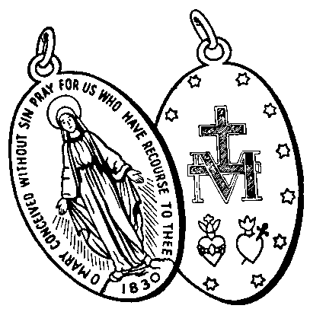Consistent with our Franciscan charism and tradition of devotion to the Blessed Virgin Mary, our Franciscan Order’s Constitutions remind the friars that in St. Maximilian’s unconditional consecration to the Immaculate, the friars have found “a concrete form of openness to the new challenges of mission.” Our province plans to more fully tap into this devotion from our Kolbean heritage. **Friar Jobe will be here with us for the weekend Masses at Mother Cabrini, November 20 – 21.**

**On Monday, November 22 at 7PM, Fr. Jobe will be leading an Interfaith/Ecumenical Prayer Service at Our Lady of Hope Parish,** seeking the intercession of St. Maximilian on behalf of those who suffer from the bonds of addiction.

Please welcome Fr. Jobe!

**33rd Sunday in Ordinary Time**

**14 November 2021**

**Introductory Rites**

**Entrance Antiphon**

The Lord said: I think thoughts of peace and not of affliction. You will call upon me, and I will answer you, and I will lead back your captives from every place. *Jer 29:11, 12, 14*  
**Gloria**

*(When it is prescribed, this hymn is either said or sung:)*  
  
**Glory to God in the highest, and on earth peace to people of good will.  
We praise you, we bless you, we adore you, we glorify you, we give you thanks for your great glory,  
Lord God, heavenly King, O God, almighty Father.  
Lord Jesus Christ, Only Begotten Son, Lord God, Lamb of God, Son of the Father,  
you take away the sins of the world, have mercy on us;  
you take away the sins of the world, receive our prayer;  
you are seated at the right hand of the Father, have mercy on us.  
For you alone are the Holy One, you alone are the Lord,  
you alone are the Most High, Jesus Christ,  
with the Holy Spirit, in the glory of God the Father. Amen.**

**Collect**

Grant us, we pray, O Lord our God, the constant gladness of being devoted to you, for it is full and lasting happiness to serve with constancy the author of all that is good. Through our Lord Jesus Christ, your Son, who lives and reigns with you in the unity of the Holy Spirit, God, for ever and ever. **Amen.**

**Daniel 12:1-3**

In those days, I, Daniel, heard this word of the Lord: “At that time there shall arise Michael, the great prince, guardian of your people; it shall be a time unsurpassed in distress since nations began until that time. At that time your people shall escape, everyone who is found written in the book.  
  
“Many of those who sleep in the dust of the earth shall awake; some shall live forever, others shall be an everlasting horror and disgrace.  
  
“But the wise shall shine brightly like the splendor of the firmament, and those who lead the many to justice shall be like the stars forever.”

**Psalm 16:5, 8-11**

**R. You are my inheritance, O Lord!**

O Lord, my allotted portion and my cup,  
you it is who hold fast my lot.  
I set the Lord ever before me;  
with him at my right hand I shall not be disturbed. **R.**

Therefore my heart is glad and my soul rejoices,  
my body, too, abides in confidence;  
because you will not abandon my soul to the netherworld,  
nor will you suffer your faithful one to undergo corruption. **R.**

You will show me the path to life,  
fullness of joys in your presence,  
the delights at your right hand forever. **R.**  
  
**Hebrews 10:11-14, 18**

Brothers and sisters: Every priest stands daily at his ministry, offering frequently those same sacrifices that can never take away sins. But this one offered one sacrifice for sins, and took his seat forever at the right hand of God; now he waits until his enemies are made his footstool. For by one offering he has made perfect forever those who are being consecrated.   
  
Where there is forgiveness of these, there is no longer offering for sin.  
  
**Gospel Acclamation**

**Alleluia, alleluia.**  
Be vigilant at all times and pray that you have the strength to stand before the Son of Man. Lk 21:36  
**Alleluia, alleluia.**  
  
**Mark 13:24-32**

Jesus said to his disciples: “In those days after that tribulation the sun will be darkened, and the moon will not give its light, and the stars will be falling from the sky, and the powers in the heavens will be shaken.   
  
“And then they will see ‘the Son of Man coming in the clouds’ with great power and glory, and then he will send out the angels and gather his elect from the four winds, from the end of the earth to the end of the sky.   
  
“Learn a lesson from the fig tree. When its branch becomes tender and sprouts leaves, you know that summer is near. In the same way, when you see these things happening, know that he is near, at the gates. Amen, I say to you, this generation will not pass away until all these things have taken place. Heaven and earth will pass away, but my words will not pass away.   
“But of that day or hour, no one knows, neither the angels in heaven, nor the Son, but only the Father.”

**Profession of Faith**

**I believe in one God, the Father almighty, maker of heaven and earth,  
of all things visible and invisible. I believe in one Lord Jesus Christ,  
the Only Begotten Son of God, born of the Father before all ages.  
God from God, Light from Light,true God from true God,  
begotten, not made, consubstantial with the Father;  
through him all things were made. For us men and for our salvation   
he came down from heaven,***(At the words that follow, up to and including and became man, all bow.)*

**and by the Holy Spirit was incarnate of the Virgin Mary,  
and became man. For our sake he was crucified under Pontius Pilate,   
he suffered death and was buried, and rose again on the third day  
in accordance with the Scriptures. He ascended into heaven  
and is seated at the right hand of the Father. He will come again in glory  
to judge the living and the dead and his kingdom will have no end.  
  
I believe in the Holy Spirit, the Lord, the giver of life, who proceeds from the Father and the Son,  
who with the Father and the Son is adored and glorified, who has spoken through the prophets.  
  
I believe in one, holy, catholic and apostolic Church. I confess one Baptism for the forgiveness of sins and I look forward to the resurrection of the dead and the life of the world to come. Amen.**

*(The Apostles’ Creed may be used instead of the Nicene Creed.)*

**The Apostles’ Creed**

**I believe in God, the Father almighty, Creator of heaven and earth,**

**and in Jesus Christ, his only Son, our Lord,**

**who was conceived by the Holy Spirit, born of the Virgin Mary,**

**suffered under Pontius Pilate, was crucified, died and was buried;**

**he descended into hell; on the third day he rose again from the dead;**

**he ascended into heaven, and is seated at the right hand of God the Father almighty;**

**from there he will come to judge the living and the dead.**

**I believe in the Holy Spirit, the holy catholic Church,**

**the communion of saints, the forgiveness of sins, the resurrection of the body,**

**and life everlasting. Amen.**

**Prayer over the Offerings**

Grant, O Lord, we pray, that what we offer in the sight of your majesty may obtain for us the grace of being devoted to you and gain us the prize of everlasting happiness. Through Christ our Lord. **Amen.**

**Communion Antiphon**

To be near God is my happiness, to place my hope in God the Lord. *Ps 73 (72):28*  
OR  
Amen, I say to you: Whatever you ask in prayer, believe that you will receive, and it shall be given to you, says the Lord. *Mk 11:23-24*  
  
**Prayer after Communion**

We have partaken of the gifts of this sacred mystery, humbly imploring, O Lord, that what your Son commanded us to do in memory of him may bring us growth in charity. Through Christ our Lord. **Amen**.

**Prayer to St. Michael**

**the Archangel**

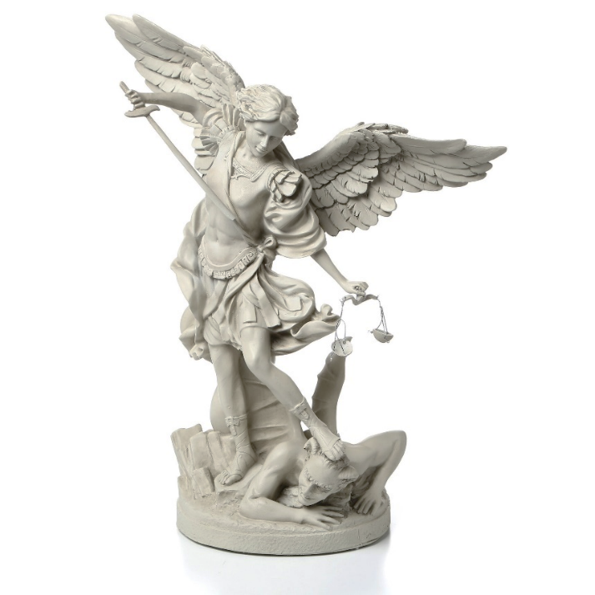**St. Michael the Archangel,**

**defend us in battle.**

**Be our defense against the wickedness and snares of the Devil.**

**May God rebuke him, we humbly pray,**

**and do thou,**

**O Prince of the heavenly hosts,**

**by the power of God,**

**thrust into hell Satan,**

**and all the evil spirits,**

**who prowl about the world**

**seeking the ruin of souls. Amen.**