**Mother Cabrini Church**

**214 North Shamokin Street**

**Shamokin, PA, 17872**

**Parish Office Hours**

**Monday through Thursday**

**8AM to 4PM**

**570-648-4512**

**Website:**

<http://wwwrevivingtogether.com/>

**Our Lord Jesus Christ,**

**King of the Universe**

**November 24, 2024**

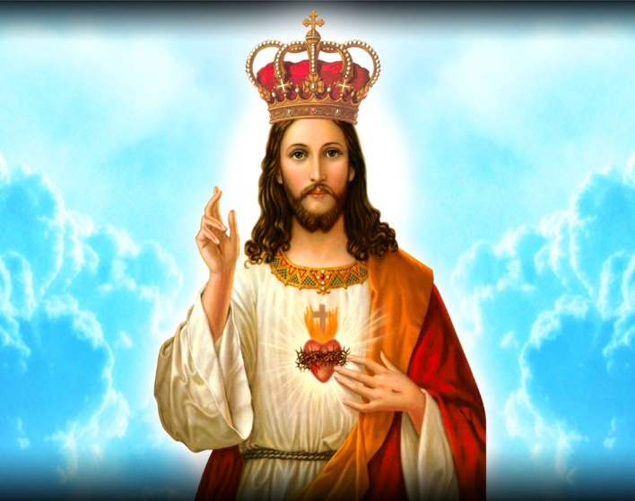

**Mother Cabrini Friary**

**Friar James Fukes, OFM Conv.,** Pastor of Mother Cabrini Church

**Friar Nicholas Spano, OFM Conv.**, Pastor

of Our Lady of Hope & St. Patrick Churches

**Friar Timothy Geiger,** **OFM Conv.,** Parochial Vicar

**Cabrini Parish Staff**

**Deacon Robert Wislock**, Pastoral Associate

**Kris Coulbourn,** Finance Manager

**Ann Marie Drust,** Parish Secretary/Cemetery Coordinator

**Jim Yost,** Maintenance

**Dennis Bobber,** Music Director

**Mary Gillam**, Religious Education Coordinator

**Cabrini Mass Schedule**

**Weekends: Saturday,** 4PM Vigil – Sunday: 8:30AM & 11AM

**Masses:** Monday through Saturday, 8AM

**Holy Days of Obligation:** As Announced

**Cabrini Confessions**

**Tuesday and Thursday:** 7:30 to 7:50AM

**Saturday:** 3:00 to 3:45PM



**Saturday, November 23**

4PM +Patrick J. Kazmerski, Jr. by Mom, Dad,

Tricia, Linda, Dave, Mike and Michael

**Sunday, November 24**

**Our Lord Jesus Christ, King of the Universe**

8:30AM ++Anthony and Jean Apollo

by Daughter, Jean Kaskie & Family

11AM Parish Family of Mother Cabrini Church

**Monday, November 25**

**Thirty-Third Weekday in Ordinary Time**

8AM ++Robert, Anna and Louise Hauer by Family

**Tuesday, November 26**

**Thirty-Third Weekday in Ordinary Time**

8AM ++Ann and William Klokis (20 Year Memorial)

by Loving Family

**Wednesday, November 27**

**Thirty-Third Weekday in Ordinary Time**

8AM ++Laura and Bill Barrett

by Bill & Pat Barrett

**Thursday, November 28**

**Thirty-Third Weekday in Ordinary Time**

8AM ++Walter and Mary Bohaczyk by Family

**Friday, November 29**

**Thirty-Third Weekday in Ordinary Time**

8AM +Peter Merena, Jr. by Son, Alan Merena

**Saturday, November 30**

**St. Andrew, Apostle**

8AM +Frank Kachinoski by Pat Barrett

4PM ++James A. Chivaroli and Helene L. Carsto

by Mary Chiavaroli and Family

**Sunday, December 1**

**First Sunday of Advent**

8:30AM +Martin Glover by Wife, Josephine

Parish Family of Mother Cabrini Church

11AM +Nicola Kolovic by Wife, Prena

**Tabernacle Flowers I**

In Memory of Patrick J. Kazmerski, Jr.

by Mom & Dad

**Tabernacle Flowers II**

In Memory of Patrick J. Kazmerski, Jr.

by Sisters, Tricia & Linda

**Tabernacle Candles**

Special Intention

**Mass Candles/Bread & Wine**

In Memory of Joseph & Helen Fedorko

by Beverly Katalenas

**Sanctuary Candle**

In Memory of Wojnarski and Boblick Families by Marie, Kathy and Tom

**Our Church Bells are Ringing this Week**

In Memory of Patrick J. Kazmerski, Jr.

by Mom, Dad, Tricia, Linda, Dave,

Mike and Michael

**Collection Totals for the**

**Weekend of November 16 & 17, 2024**

**Offertory: $3,183.00**

**Votives: 117.00**

**Closing of 40 Hours: 416.00**

**Parish Property Insurance: 173.00**

**Parish Dues: 308.00**

**Miscellaneous: 169.00**

**Total: $4,366.00**

**Franciscan Missions: $ 20.00**

**World Missions: $ 20.00**

**Matthew 25: $ 521.00**

**Franciscan Seminarians: $ 566.00**

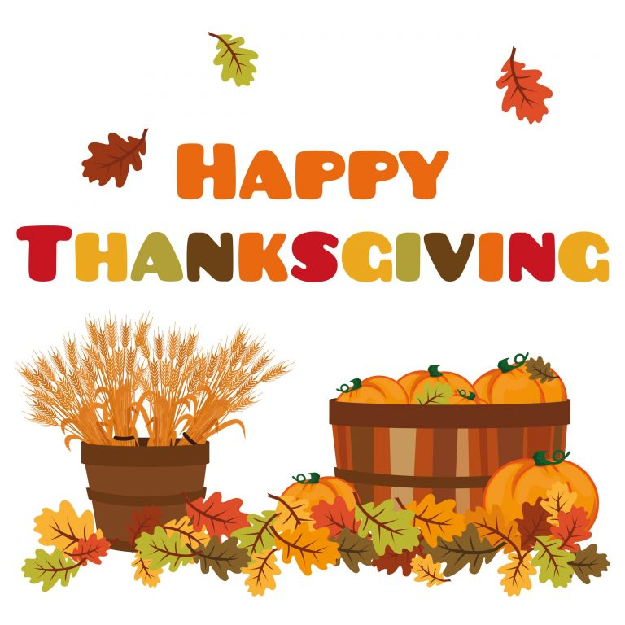

**PLEASE NOTE:** In observance of the Thanksgiving Holiday, our Parish Office will close at 12Noon on Tuesday, November 26th and re-open on Monday, December 2nd.

**Many Thanks! & Applause**

**To Our Volunteers!**

**Pierogi Workers and Chicken BBQ Crew:** We’ve had a fine group of dedicated pierogi workers at our Pierogi making project and our Chicken BBQ last month.

**Total profit for Pierogi Sales are $3,623.79**

**Total Profit for Chicken BBQ Dinners: $2,511.57**

Both of our events, the Pierogi Sale and the Chicken BBQ were a great success. I thank all our “customers” for their support of our events and once again, salute our wonderful volunteer teams.

It was a pleasure to see the wonderful turnout of volunteers and the positive, hardworking spirit among everyone.

Thank you to all!! Friar Jim

**Because of the Thanksgiving Holiday, anyone that is planning to attend the Dan Orland concert is asked to purchase a ticket this coming week or contact the parish office at 570-648-4512 so that**

**we can get a count prior to**

**the concert.**

**Mother Cabrini Memorial**

**In Memory of Tony Misunas**

$20 by Ed and Tracey Madden

**Our Lord Jesus Christ,**

**King of the Universe**

**First Reading: Daniel 7:13-14**

Daniel describes the one who will appear on the clouds of heaven and receive glory. People of every language will serve this one, and his leadership and community will be his forever.

**Second Reading: Revelation 1:5-8**

Jesus is so powerful, he is the ruler of kings. He loved us enough to free us from sin, and so he will be glorified forever. He will appear again and be seen by all the people of the earth. God calls himself the first and last, "the One who is and who was and who is to come," reminding all people that God will remain with us always.

**Gospel: John 18:33b-37**

Pilate asks Jesus if he is a king. Jesus explains that his kingdom is not of this world. Pilate asks again if Jesus is a king, to which he replies, "I came into the world to testify to the truth. Anyone committed to the truth hears my voice.”



**Advent Penance Services**

**Sunday, December 8th**

**Second Sunday of Advent**

**Mother Cabrini 1PM and St. Patrick’s 3PM**

**Tuesday, December 10th**

**Our Lady of Mount Carmel 6:30PM**

**Wednesday, December 11th**

**Holy Rosary 6:30PM**

**Monday, December 16th**

**Holy Angels 7PM**

**Please Pray For the Sick***,* especially, Ann Barber, Bob Hauer, Jim Logic, Kapukui Sykes, Candida Davis, Dennis Shuey, Pete Ginther, “Henry", Connie Yucha, Roberta Jasper, Sylvia Pappas, Katie Bolick, Connie Fabrizio, Sharon Rome, Robert Wieland, Timber Buckwash, Anita Shaffer, Rosemary Krushinskie, LeAndre Hoover, Lone Wolf, Joe Mazzatesta, Pat Jaworski, Pastor Paul Eby, Gina Fox, Casper Burns Lorraine Gusick, Tammy Neron, Alex Stefanowicz, Shirley Stefanowicz, Elizabeth Rebuck, Jaden Leiby, Joy Knapik, Sharon Casper, Rosie Purcell, Pat & Peggy Kazmerski, Tammy (Laczkowski) Le, Desiree Castro, Helene McGinley, Elizabeth Purcell, Carol Fegley, Lorraine Kinder, Jim Culp, Sandy Boyd, Jackson Floyd, Andrew Wislock, Cassondra Senoski, Helen Pasierb, Mark Senoski, Carl T. Bielski, Mary Ellen Candelora, Mary Ann (Anderson) Barrett, Elaine Rado, Theresa Krushinskie, Kathleen Kleskie, Karen Buranich, Kevin Hauer, Brian Shaffer, Nick Thorpe, Lori McCabe, Beverly Katalenas, Una McManus, James Sandri, Noreen Germak, Scott Wieland, Edward Yeager, John Laskoski, Steve Novak, Tracie Hartman, Mary Ann Pacocha, Barbara Shevitski, John Kehler, Ty Beeman, Aerica Richardson, Sue Cantore, Chuck Pensyl, Jr., Luke Dietterick, Special Intention, Lois Topolski, Stephen Zarick, Bob Derk, Huxley Hoffman, Gloria Koyack, Arthur Crone, Jacob Lupotsky, Michelle Williams, Rosemary Jacoski, Karima Starke, Jeanie Hickman, Brian Hickman, Amber Sadowy, Kelsey Matchock, Fern Gonsar, Jesse Procopio, Michael Wasilewski, Brittney Reed, Kenneth Marut, Alexa Blugis and Sherry Dampman.

**Lottery Calendars**

**for January 2025**

are on sale at the parish office at $5.00 each. Keep in mind that these will make great Christmas Gifts and Stocking Stuffers!



***PLEASE REMEMBER OUR TROOPS AND THEIR FAMILIES IN YOUR PRAYERS.***

**Deacon’s Corner**

**Thanksgiving Day**

This week, on Thursday, we will celebrate Thanksgiving Day, a national holiday. During the mass on this day, we hear in the Gospel of St. Luke that Jesus meets and cleanses ten lepers in a village. Christ asks them to go to the priests and “show themselves”. Only one of these lepers return to Jesus to thank Him. Our Lord says, “Ten were cleansed, were they not? Where are the other nine?” Then, Jesus says to the one man who was healed, “Stand up and go; your faith has saved you.”

On this day, let us count our blessings, acknowledge God’s love and mercy in our daily lives, and thank Him for His goodness. As Catholics, Thanksgiving Day also has a deeper meaning for us. We need to be thankful for the supreme sacrifice that Christ offered on our behalf on the Holy Cross as He conquered sin and death for each one of us.

As we gather for our Thanksgiving meal, may we pray, *“*Heavenly Father, we gather together today with hearts filled with gratitude. This meal we share reminds us of the endless blessings You’ve bestowed upon us. We pray in thanksgiving not only for this food we share, but in all the ways You’ve shown us Your love. In Jesus’ name we pray. Amen.”

Happy Thanksgiving. God bless you and all your family members.

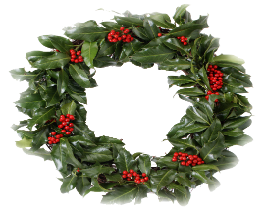**Beautiful Fresh Christmas Wreaths**

FAR Better Together is once again selling large, fresh, mixed green boughs Christmas Wreaths. Cost is $35 decorated or $30 plain.

Contact: [**shamokinb2g@gmail.com**](mailto:shamokinb2g@gmail.com) to order and for payment information. Or call Susan Vanaskie Ward to place your order @ 570-486-3316. Delivery to homes and businesses November 29 to Dec 3.

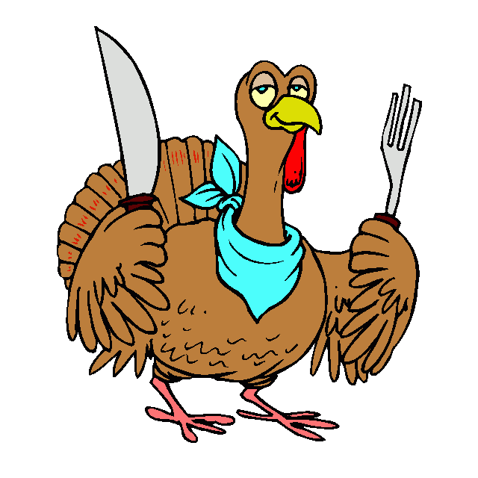**Shamokin K of C**

**Council 458 Annual**

**Thanksgiving Dinner:**

The Shamokin Knights of Columbus will be hosting their annual Thanksgiving dinner on Thursday November 28, 2024 at the Council Hall at 400 E. Independence St. Shamokin from 11:00 - 2:00. The meal consists of Turkey, mashed potatoes, gravy, green bean casserole, a role and desert.  All are welcome and meals are available for both eat-in and out.  The meal is served at no charge!  Come and spend some fellowship on this Holiday.  If you need to have a meal(s) delivered to you **please contact the parish office no later than this Monday November 25, 2024.** If you would like to help to defray the cost of the meal, we are accepting monetary donations as well as donations

of frozen turkeys.  Please contact the parish office to arrange donation of turkeys.

**Friar Jim, Friar Tim and the Staff at Mother Cabrini wish all of you a Happy Thanksgiving!**

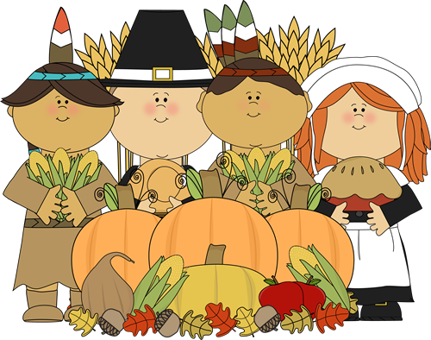

**\*\*\*\*\*\*\*\*\*\*\*\*\*\*\*\*\*\*\*\*\*\*\*\*\*\*\*\*\*\*\*\*\*\*\*\*\*\*\*\*\*\*\*\*\*\*\*\*\*\*\*\*\*\*\*\*\*\*\*\*\*\*\*\*\*\*\***

**DAN ORLANDO CONCERT. . .**

**Next Sunday, December 1st**

**Nationally-acclaimed Singer, Songwriter/Pianist**

**Dan Orlando Solo Concert - Sunday, Dec.1, 2024**

**Brady Fire Co. Banquet Hall, Ranshaw**

**Doors open at 1PM – Concert 2 to 4PM**

**$25 per person – Light refreshments/cash bar.**

**Proceeds benefit Mother Cabrini Church**

**Tickets are available at Mother Cabrini Parish**

**Office during office hours and at**

**Lourdes Regional School.**

**Because of the Thanksgiving Holiday, anyone that is planning to attend the Dan Orland concert is asked to purchase a ticket this Monday or Tuesday or contact**

**the parish office at 570-648-4512 so that we can get**

**a count prior to the concert. Limited amount of tickets will**

**be sold at the door the day of the concert.**